# Instructions

First of all you can choose any logo, colors, style of navigation and layout design as you like.

# Discussing about mock up slides

## W1

1. The landing page where both sellers and buyers will visit, they should be able to login or sign up.
2. They can also click the buttons 'What’s cooking' or 'Sell food': To show a slideshow

on how the process is done or works (3 slides would be good). For example:

* + Slide1 will tell them to register (with an image or text your choice)
  + Slide2 can show them a map with food tag (like image below)

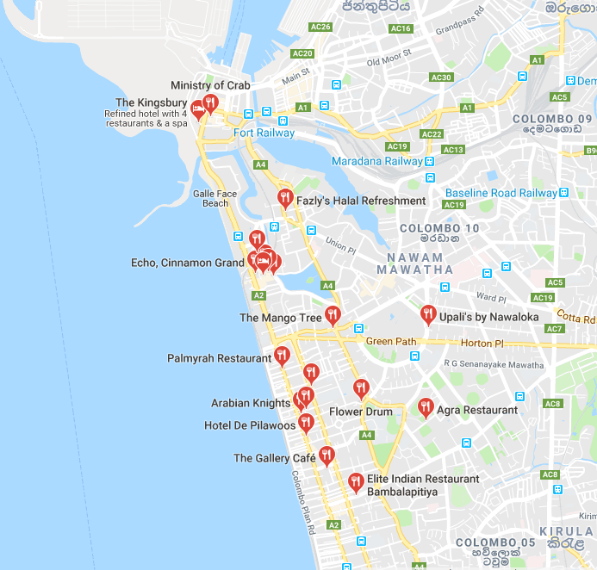

* + Slide 3 can show the order process (with an image or text your choice)

- Like that you do the same thing if they click 'sell food'

I think it’s easier if you can use CSS and display which ever slide according to user click

[Or]

You can just make them login or register before they can do any actions...its upto you. I prefer the slide show instruction method, if you can.

**[More instructions for w1]**

* Signup can at least send a ‘thank you for registering’ or activate account if u can… with any good mail API used with laravel framework.
* There should be a password reset mechanism like forgot password, etc.
* If you want: you can also add the social sign in method where the user can use FB and login and the data will be automatically saved to database.

## W2

The side navigation panel which can be toggled on clicking the ‘hamburger or toggle button’

Nothing much there just the list of links for the users to click and move. (Make it responsive)

## W3

* Registering area, it can be any design, but please take the mandatory data like:
* Name: (do not accept anything other than letters) and SEX
* Telephone: (format will be (+94) 7777-34542)<- cell phone
* NIC: 10 character (varchar preferred) – format will be: 913105214V (Unique)
* Email: validate
* Passwords: validate

**Note: Validation will count, so please validate and send alerts on error or success. You can use Alertify.js or similar for a nice alerts library.**

Once registered they can login (you can redirect may be?)

## W4

1. This is the area where a person who wants to sell food will be taken to.
2. All the details should be filled by the seller before they can click on ‘upload to food map’
3. Once uploaded, the page with map (W5) will have it on location and show sellers name on map.
4. And the sellers name should be displayed on the list…so if 3 sellers are uploading food details, the panel with sellers list will have three names…If the buyer click anyone, it will take him to that seller’s food order, where he can cancel and go back to map or go with order.

## W5

The Main part of the system, Here the map should be displayed nicely, with location tags of the sellers within 10 kilometer radius…The buyers location should be detected automatically and load them in the input area, after they give permission…The input location, area code and search radius can also be manually adjusted…Keep a fixed radius of minimum 5 KM to 25KM maximum, so user can only select, 5,10,15,20 and 25 KMs.

**IF you have any suggestions or a better way to improve this idea please discuss AND we can work on it… the simpler the better…Deadline is a serious issue here…**

## W6

Here is where the buyer selects the portions of food he wants…and the amount will be calculated automatically for the portions he takes…food details can be loaded from DB and shown and also the sellers info from DB…for example if there are 2 Pizza and each cost 10$, then if I select 2 portion the amount should be 20$...

## W7

The order confirmation page (they can leave this page if they don’t like the food displayed)

Confirm order ( I don’ think this page is needed?) but if you think its good you can add it…its just something I thought for guest users who wants to buy food….but I think it’s alright you can just load information from sessions or database.

## W8

Once order is confirmed, redirect to food map…and before that send a text and email notification to the seller so they can pack it and keep it ready.